**REPORT LAB 3**

**Assignment 1:**

Source code:

#Laboratory Exercise 3, Sample Code 1

.text

li $s1, 3 # i = 3

li $s2, 5 # j = 5

li $t1, 7

li $t2, 9

li $t3, 11

start: slt $t0,$s2,$s1 # i < j ?

bne $t0,$zero,else # …

addi $t1,$t1,1 # …

addi $t3,$zero,1 # …

j endif # …

else: addi $t2,$t2,-1 # …

add $t3,$t3,$t3 # …

endif:

# In this exercise, init i = 3, j = 5, $t1 = 7, $t2 = 9, $ t3 ==11

# bne means branch not equal

# so the clauses in start( the 2 addi runs)

**Assignment 2:**

Source code:

#Laboratory 3, Sample Code 2

.data

A: .word 1, 2, 3,4,5

.text

li $s1, -1 # init i = -1

li $s3, 5 # number = $s3=5

li $s4, 1 #step = $s4 = 1

li $s5, 0 # sum = $s5 = 0

la $s2, A # load address of A into $s2

loop: add $s1,$s1,$s4 #i=i+step

add $t1,$s1,$s1 #t1=2*s1

add $t1,$t1,$t1 #t1=4*s1

add $t1,$t1,$s2 #t1 store the address of A[i]

lw $t0,0($t1) #load value of A[i] in $t0

add $s5,$s5,$t0 #sum=sum+A[i]

bne $s1,$s3,loop #if i != n, goto loop

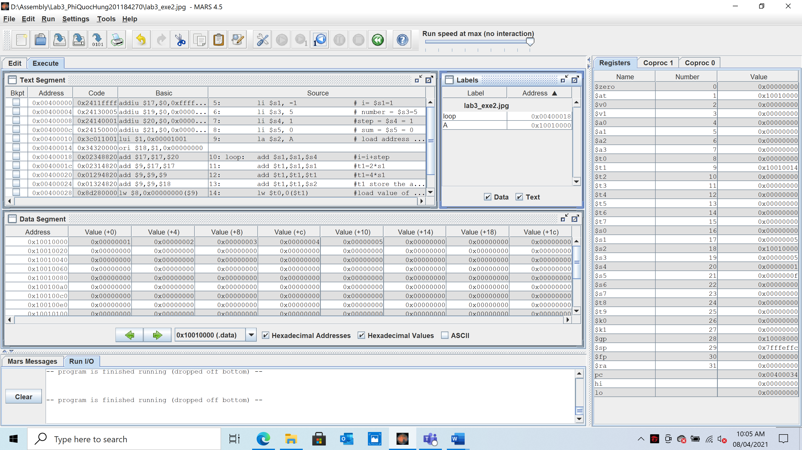

**Assignment 3:**

Source code:

#Laboratory Exercise 3, Sample Code 3

.data

test: .word 2 # chang test case here

.text

li $s2, 5

li $s3, 7

la $s0, test #load the address of test variable

lw $s1, 0($s0) #load the value of test to register $t1

li $t0, 0 #load value for test case

li $t1, 1

li $t2, 2

beq $s1, $t0, case_0

beq $s1, $t1, case_1

beq $s1, $t2, case_2

j default

case_0: addi $s2, $s2, 1 #a=a+1

j continue

case_1: sub $s2, $s2, $t1 #a=a-1

j continue

case_2: add $s3, $s3, $s3 #b=2*b

j continue

default:

continue:

Case 0:

Case 1:

Case 2:

So we can see that the switch-case did everything correctly

**Assignment 4:**

a, i<j

slt $t0,$s2,$s1

* slt $t0,$s1,$s2

b.i>=j

slt $t0,$s2,$s1

bne $t0,$zero,else

* slt $t0,$s2,$s1
* bne $t0,1,else

c.i+j<=0

.data

data: .text

li $s1,20

li $s2,10

start:

addi $s1,$s1,$s2

slt $t0,0,$s1 # j < i ?

bne $t0,1,else #...

addi $t1,$t1,1 # ...

addi $t3,$zero,1

j endif

else:

addi $t2,$t2,-1 # ...

add $t3,$t3,$t3

endif:

d.i+j>m+n

.data

data: .text

li $s1,20

li $s2,10

li $s5,13

li $s6,15

start:

addi $s1,$s1,$s2

addi $s4,$s5,$s6

slt $t0,$s4,$s1

bne $t0,$zero,else

addi $t1,$t1,1

addi $t3,$zero,1

j endif

else

addi $t2,$t2,-1

add $t3,$t3,$t3

endif:

**Assignment 5:**

1. Add command:

‘Slt $t2, $s1, $s3’

After “add $s1, $s1, $s4”

1. Add command:

“slt $t2, $s3, $s1”

After “add $s1, $s1, $s4”

1. Add command:

“sle $l2, $zero, $s5”

After “add $s1, $s1, $s4”

1. Add command:

“beqz $t0, endloop

Bne $t2, $zero, loop

Endloop:”